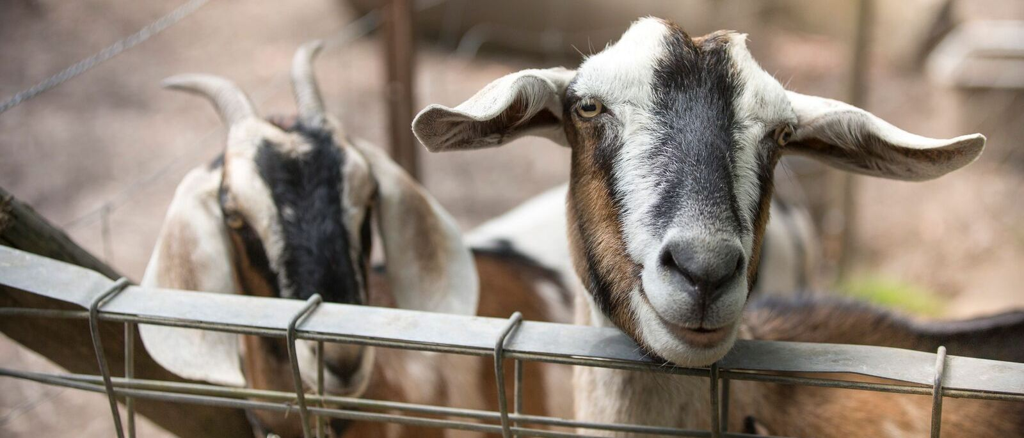
About the farm
Lesley Porter founded the Good Life Farm in 2005 with the vision of contributing to the health and well being of young people who are experiencing a diverse range of emotional, social and physical challenges.
She does this in an extraordinary way - putting troubled lives back on track by forging strong bonds with animals and nature.
“I see a bit of myself every day in these kids. I see their struggles. I see their happiness. I see their connection to the animals and I see that this place gives them a reason to live.”
Founder, Lesley Porter

The Good Life Farm Limited (ABN 60 166 003 854) is a self sustainable farm that provides environmental, life skills and animal studies programs to at-risk youth.
It is registered with the Australian Charities and Not-for-profits Commission (ACNC) as a charity, and operates under a governing constitution.

Contact us
568 Chum Creek Road
Chum Creek Victoria 3777
Phone: 03 5962 5609
Email: goodlifefarm@iinet.net.au
Web: goodlifefarm.org.au
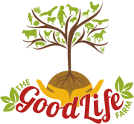

The Good Life Farm:

Grassroots healing
Helping our youth
The Good Life Farm can help with a range of emotional and behavioural presentation in children and youth. These may involve emotional and/or social challenges, personal growth, life skills development, or simply promoting general well being.
Some specific reasons and challenges your child may have been referred to The Good Life Farm include:
- general anxiety
- stress management
- performance anxiety
- mood disturbances
- confidence issues
- self identity problems
- communication skills
- relationship skills
- life experience
- social isolation
- bullying
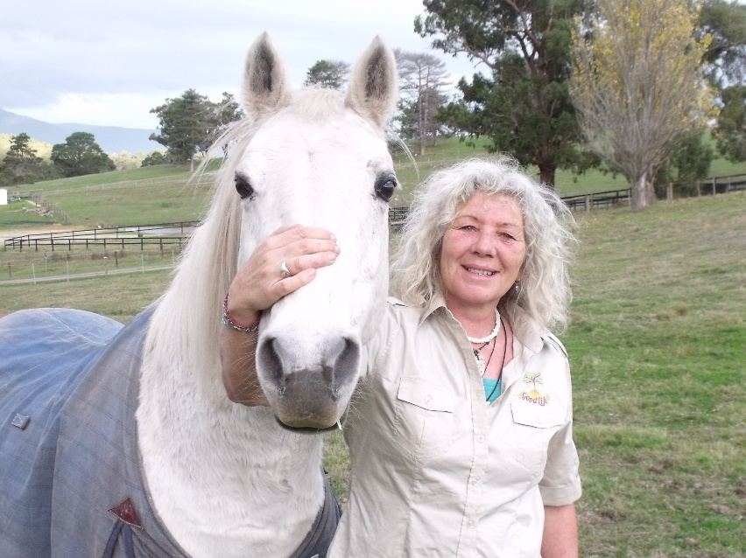
- friendship problems.

What we do
The Good Life Farm focuses on developing quality relationships using a clientcentred approach consisting of three core values which govern the young person-staff interaction:
1. Genuineness. Staff are congruent between their actual self and their helping self and are genuinely interested in the client.
2. Unconditional positive regard. Accept the young people attending the farm unconditionally and without passing judgment.
3. Empathic understanding. Show the young people empathy, acceptance and an understanding of their behaviour.
This approach enables young people to learn how to behave appropriately in interpersonal interactions, reduce disruptive behaviours and guide and encourage self discovery and exploration.
At the Good Life farm young people facing a range of personal challenges and difficulties are welcomed into a safe and transformative natural environment that allows distressed young minds to develop adaptive coping strategies and a sense of self. This enables our young people to discover their path towards a better future.
For more information on the Good Life Farm therapeutic model please go to: goodlifefarm.org/therapeutic-model

Life and social skills program
The Good Life Farm’s ten week course is a life and social skills program for young people aged 7 to 17. It offers an in-depth learning experience that concentrates on personal development in a supportive and safe environment.
It is specifically tailored towards youth at high-risk, those with a mild intellectual disability and young people who are disengaged from society.
Our young people get a taste of what it’s like to live and work on the farm. They experience our permaculture philosophy first hand and have the opportunity to get up close and personal with some of our farm animals.
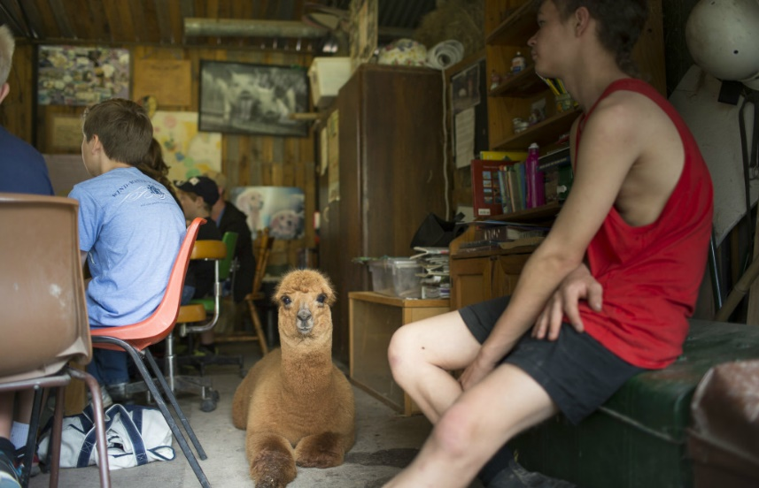

Corporate events
Contact the office for more information on hiring our our facilities for your corporate event.

